**ABSTRACT**

The product is a web-based application that provides recommendations in regard to holiday destination best suited to customers based on analysis of travel data. The analysis takes into consideration customer’s physiological, psychological, demographical data. Client can fill in details about the kind of group he/she will be travelling in, budget and also the type of destination.

According to the details entered by client, the system will recommend a travel destination best suited to their need. Admin will confirm bookings generated by the users.

It will also provide optional features such as Recommend hotels in nearby vicinity and places that are a must visit.

**CHAPTER 1:**

**INTRODUCTION TO THE PROJECT**

Travelogue Trip Planner is a web-based project that makes it easy for users to plan their holiday in a matter of minutes. By pre-planning their dream holiday, the user can then proceed to book with ease. Travelogue is an online travel management system. It aimed to offer a range of best-value services to ensure that tour runs smoothly and efficiently.

A lot of effort is required when one needs to decide or plan the holiday destination. But travelogue makes that work a lot easier. The user just has to specify the type of destination he or she is looking for along with the number of people who will be travelling and the suitable destinations will show up.

A user can login or create his or her own account and can navigate between multiple destinations depending upon what he or she likes best.

**CHAPTER 2:**

**CLIENT SURVEY/ RESULT**

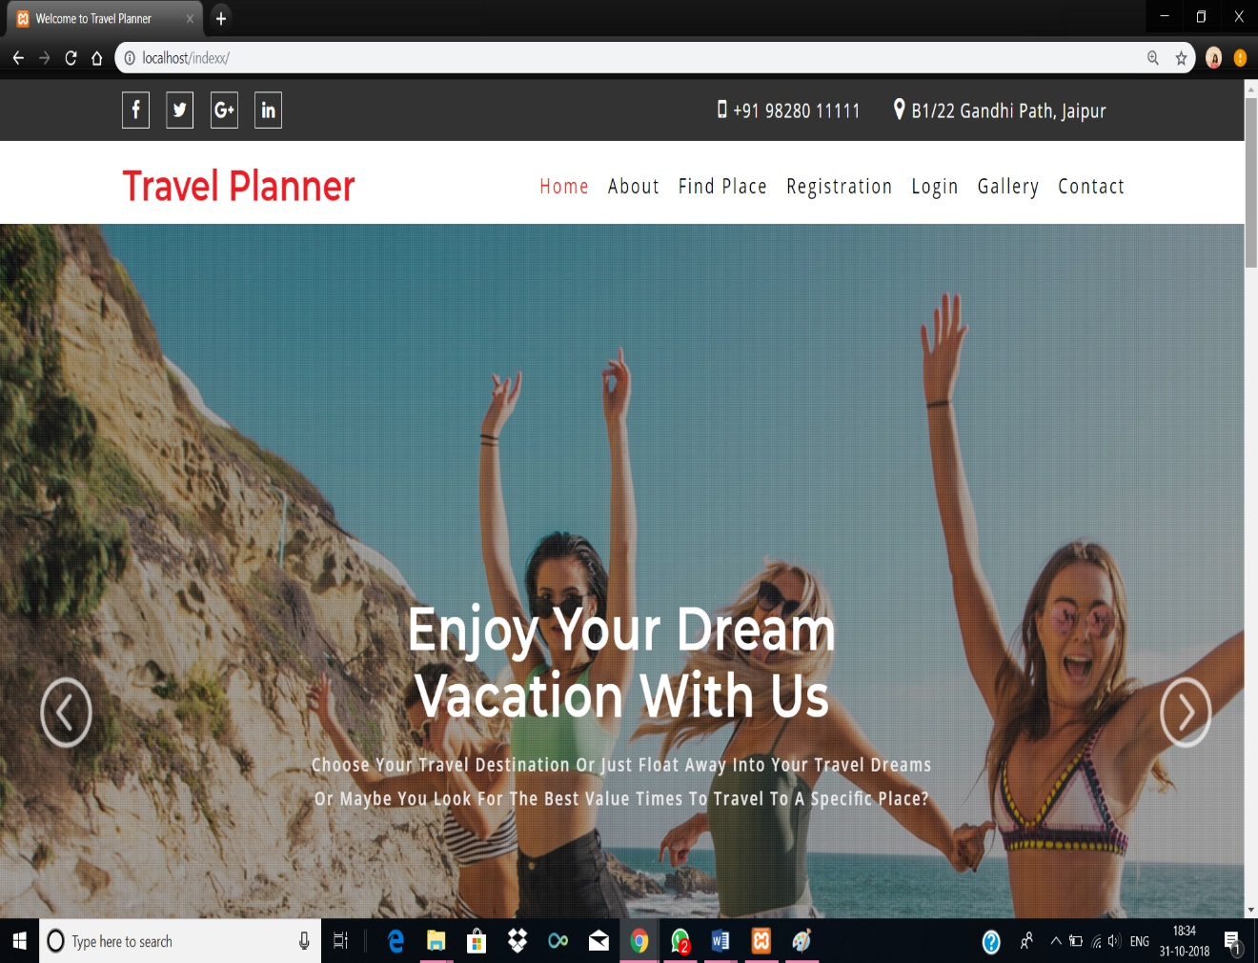

**Figure 2.1: Front Page**

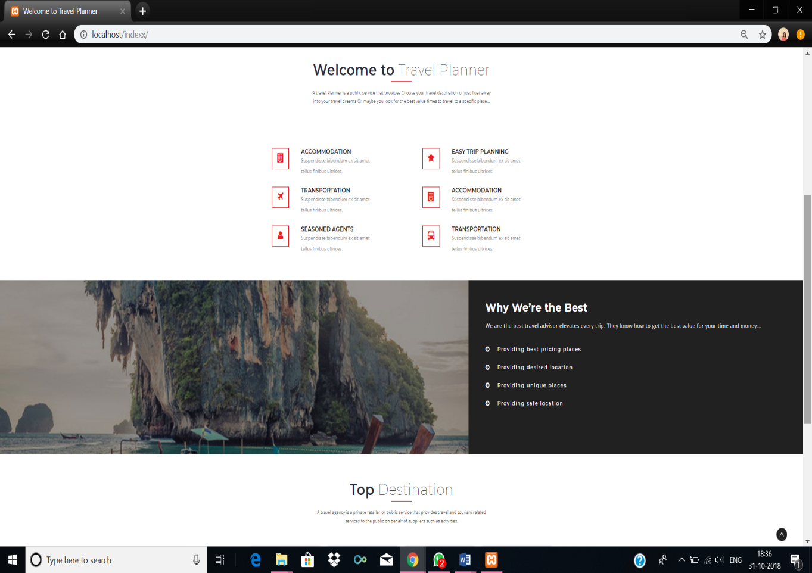

**Figure 2.2 : Front Page**

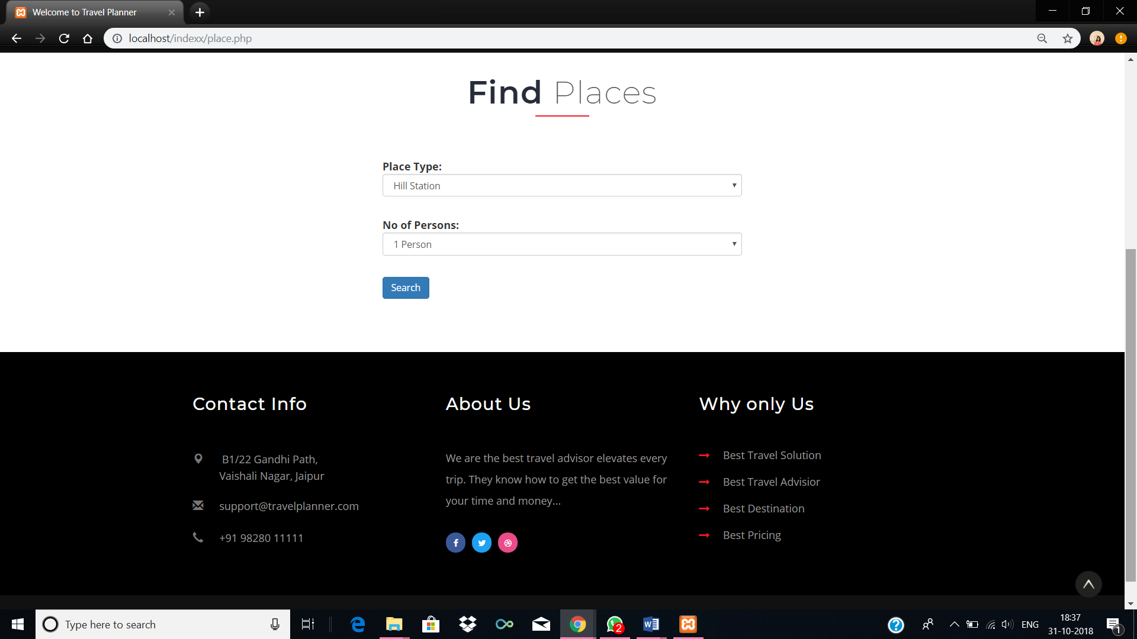

**Figure 2.3 : Find Places**

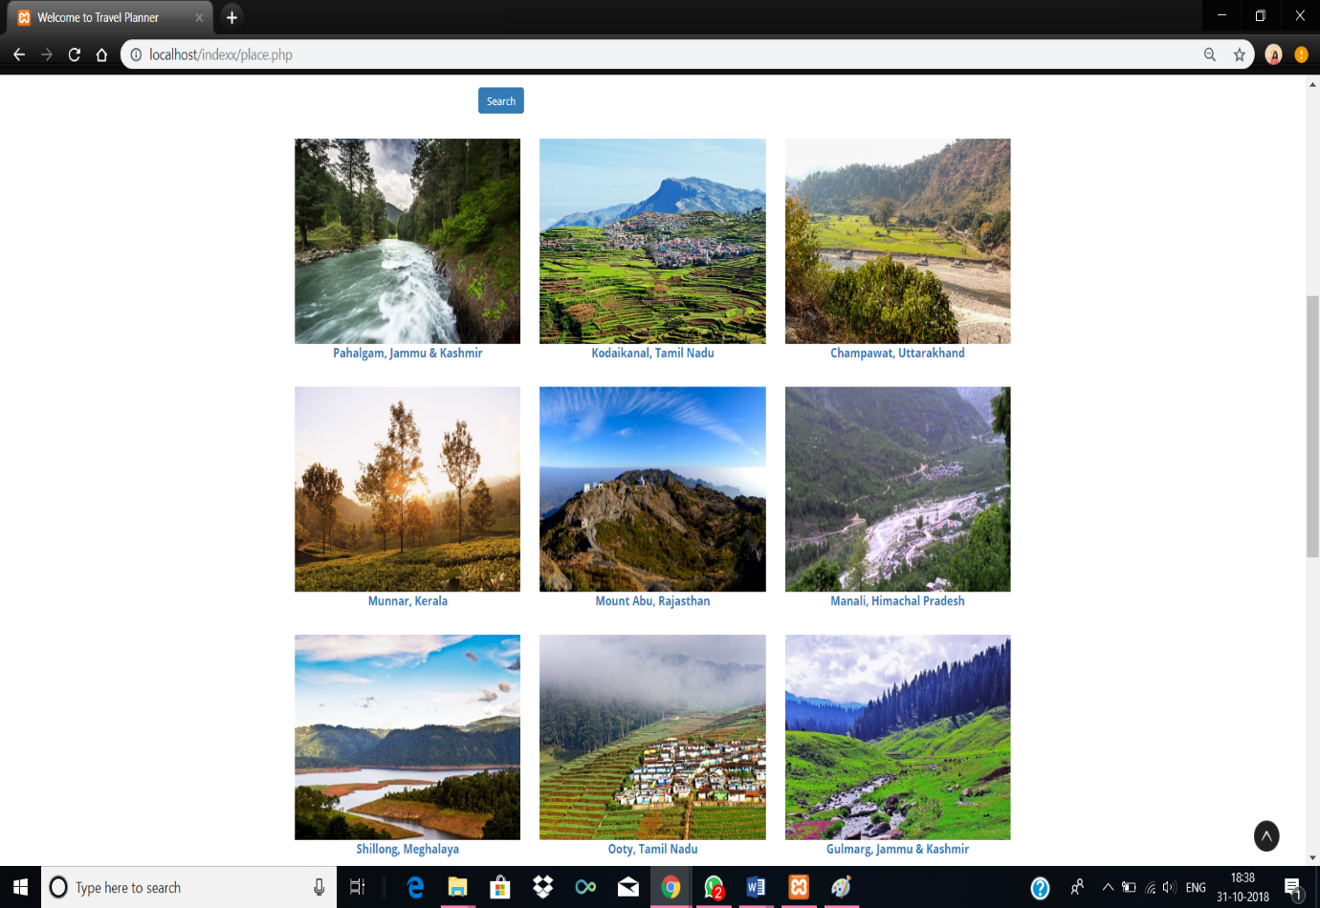

**Figure 2.4 : Places Result**

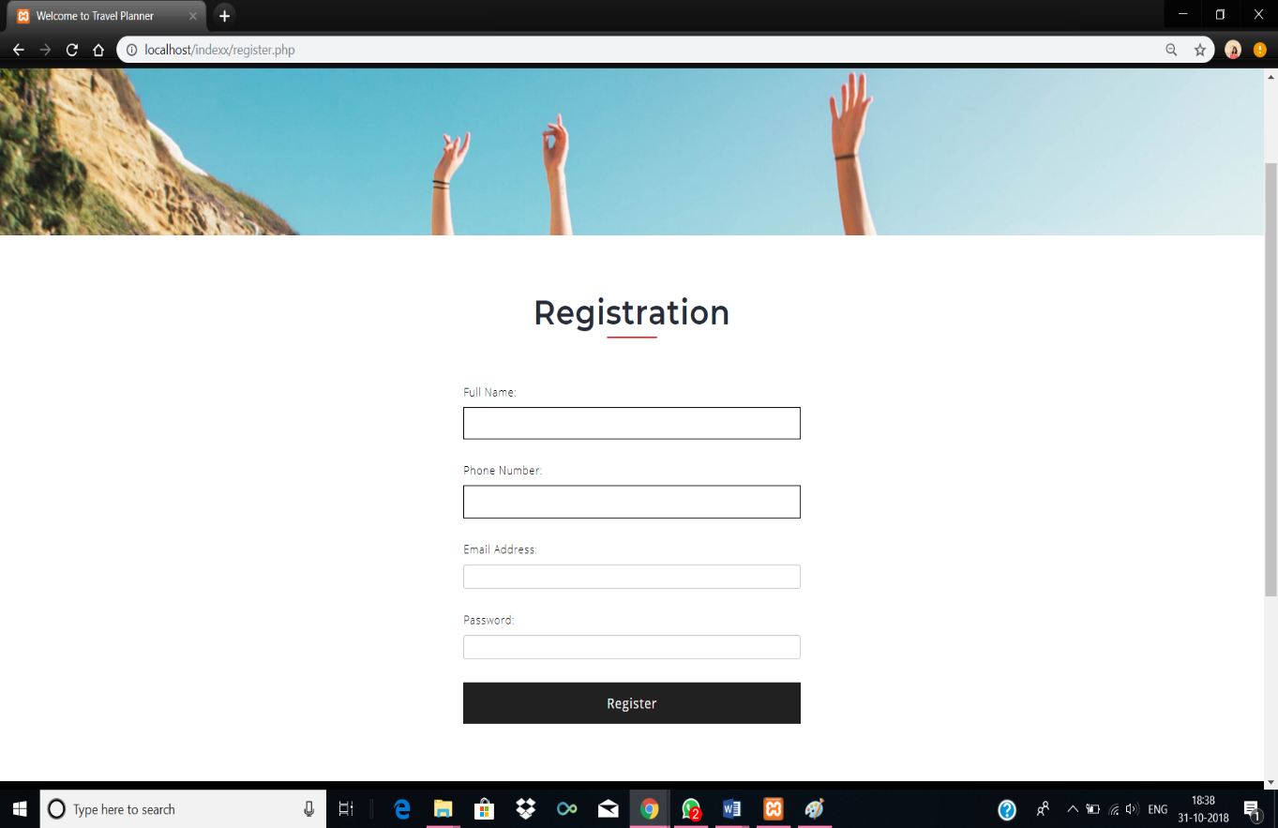

**Figure 2.5: Registration Page**

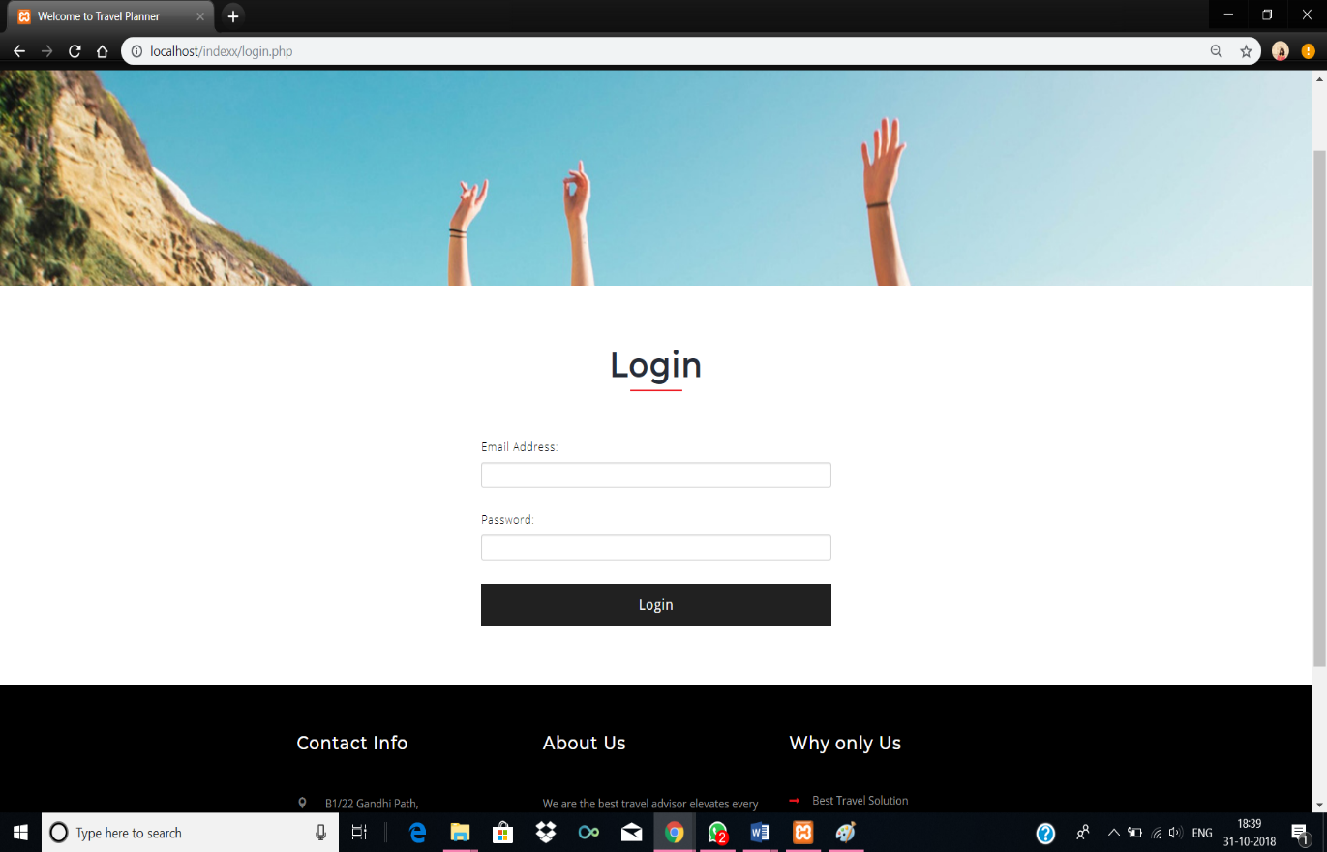

**Figure 2.6: Login Page**

**CHAPTER 3:**

**SRS**

**CHAPTER 4:**

**SDD**

Software Design Document

For Minor Project

Travelogue



|  |  |
| --- | --- |
| Prepared by:  Aparna Tyagi  Pooja Sharma | Guide:  Ms. Sita Gupta  Asst. Professor, PCE |
| Department of Information Technology,  Poornima College of Engineering | |
| October, Session – 2018-19 | |

**Index**

|  |  |
| --- | --- |
| Table of Contents | Page No. |
| 1. Introduction | 1 |
| **2. Architectural Design (System Flow Chart,)** | 2 |
| **3. UML Diagram (Class Diagram, Deployment Diagram)** | 3,4 |
| **4. Database Diagrams** | 5 |
| 5. GUI Design | 6-8 |
| 6. References | 9 |
| 7. Guide’s Comments | 10 |

**Introduction**

Travelogue Trip Planner is a web-based project that makes it easy for users to plan their holiday in a matter of minutes. By pre-planning their dream holiday, the user can then proceed to book with ease. Travelogue is an online travel management system. It aimed to offer a range of best-value services to ensure that tour runs smoothly and efficiently.

A lot of effort is required when one needs to decide or plan the holiday destination. But travelogue makes that work a lot easier. The user just has to specify the type of destination he or she is looking for along with the number of people who will be travelling and the suitable destinations will show up.

A user can login or create his or her own account and can navigate between multiple destinations depending upon what he or she likes best.

**Architectural Design**

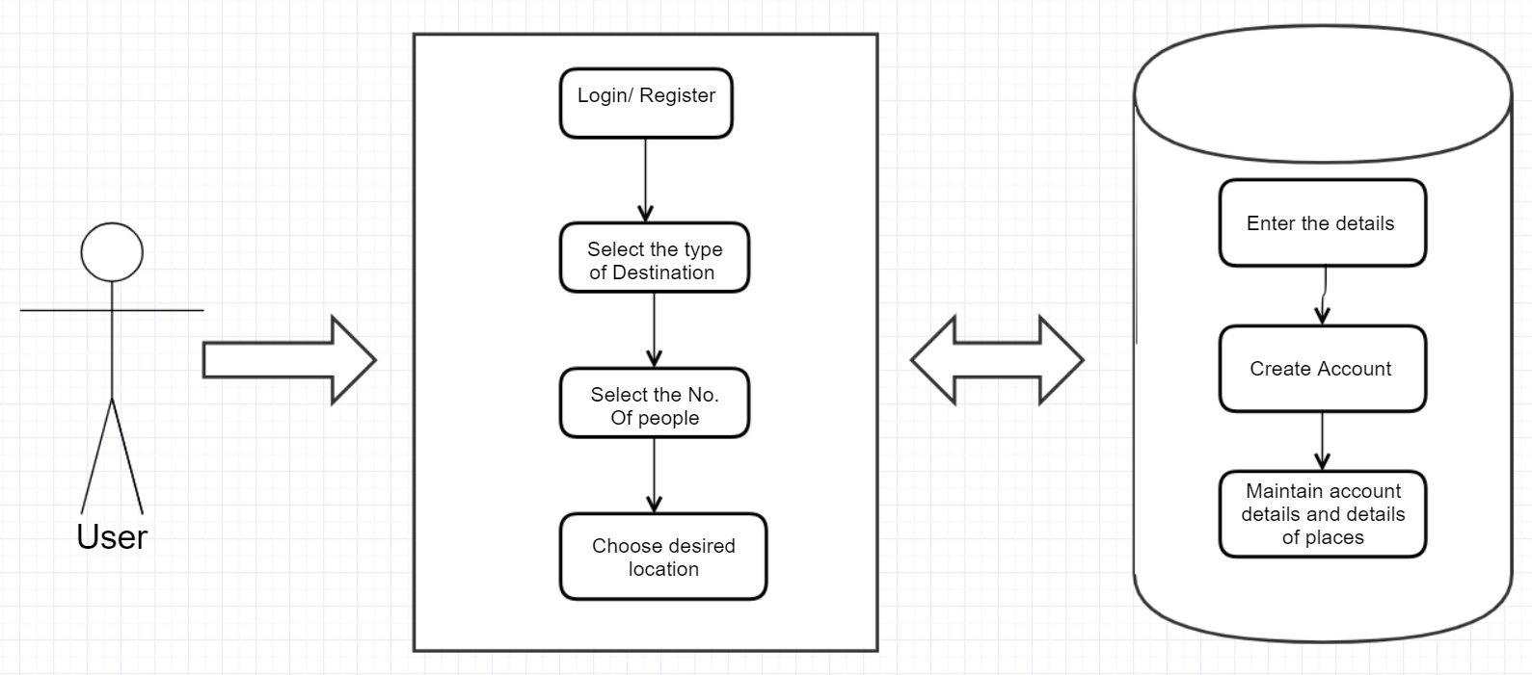

**Flow Chart**

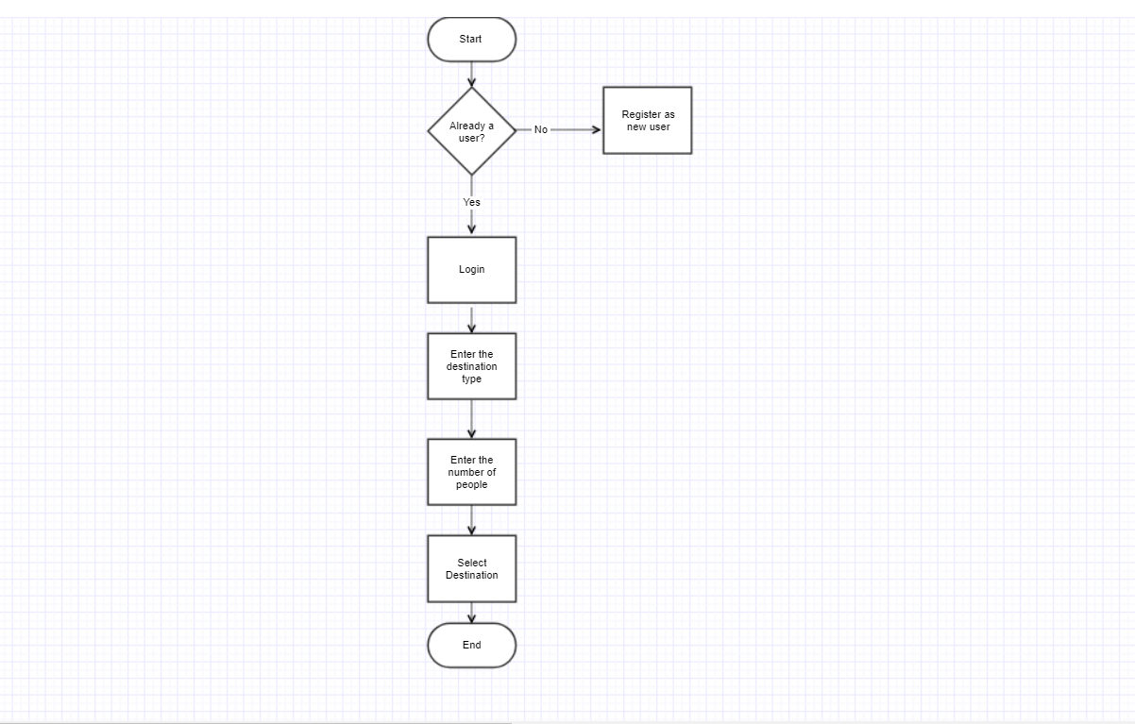

**Class Diagram**

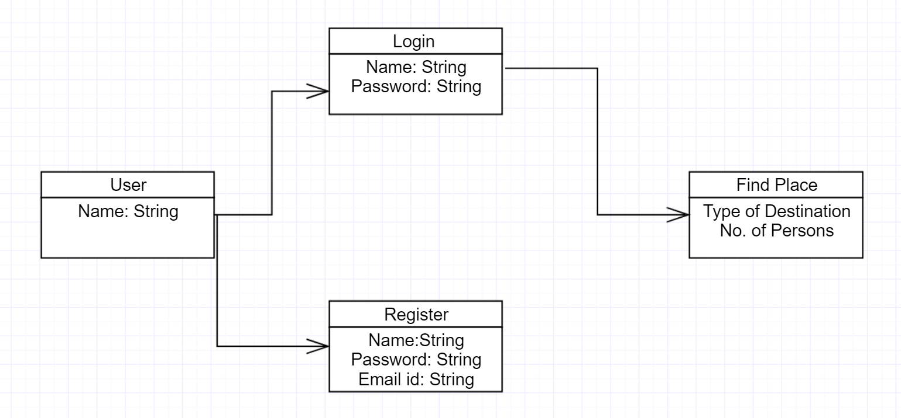

**Deployment Diagram**

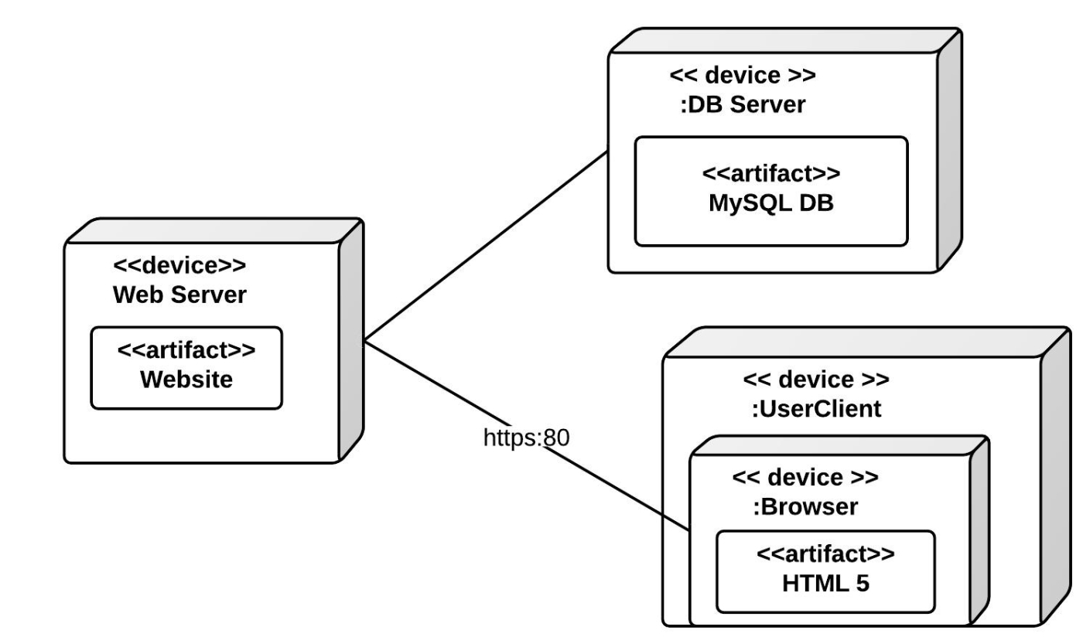

**Database Diagram**

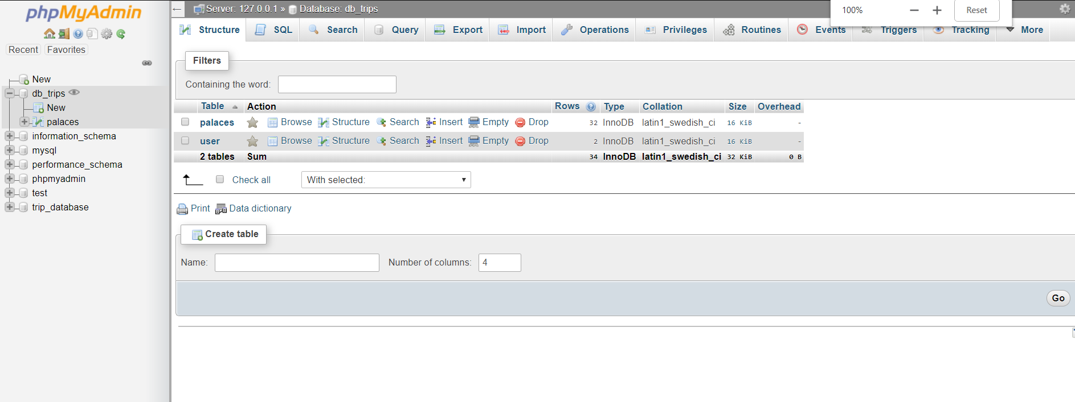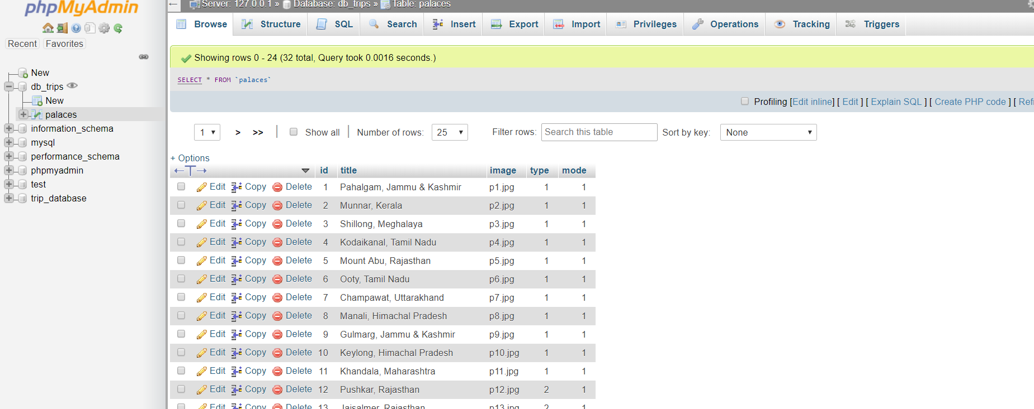

**GUI Design**

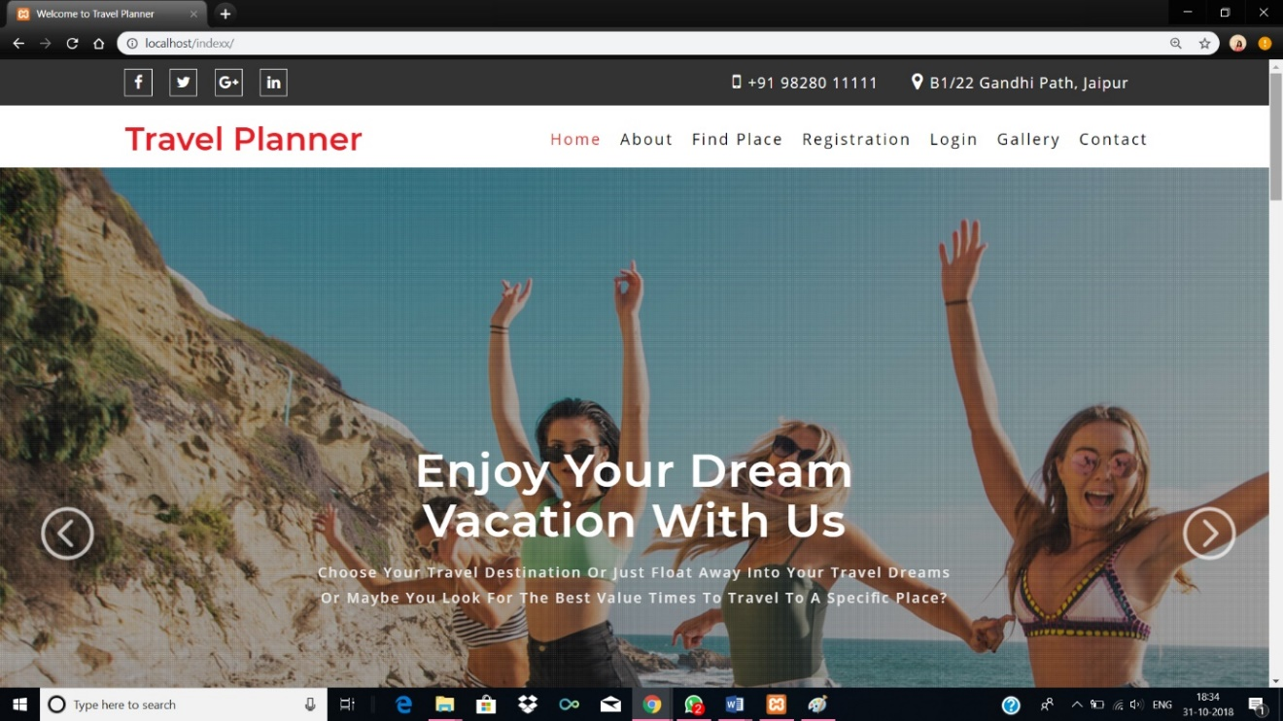

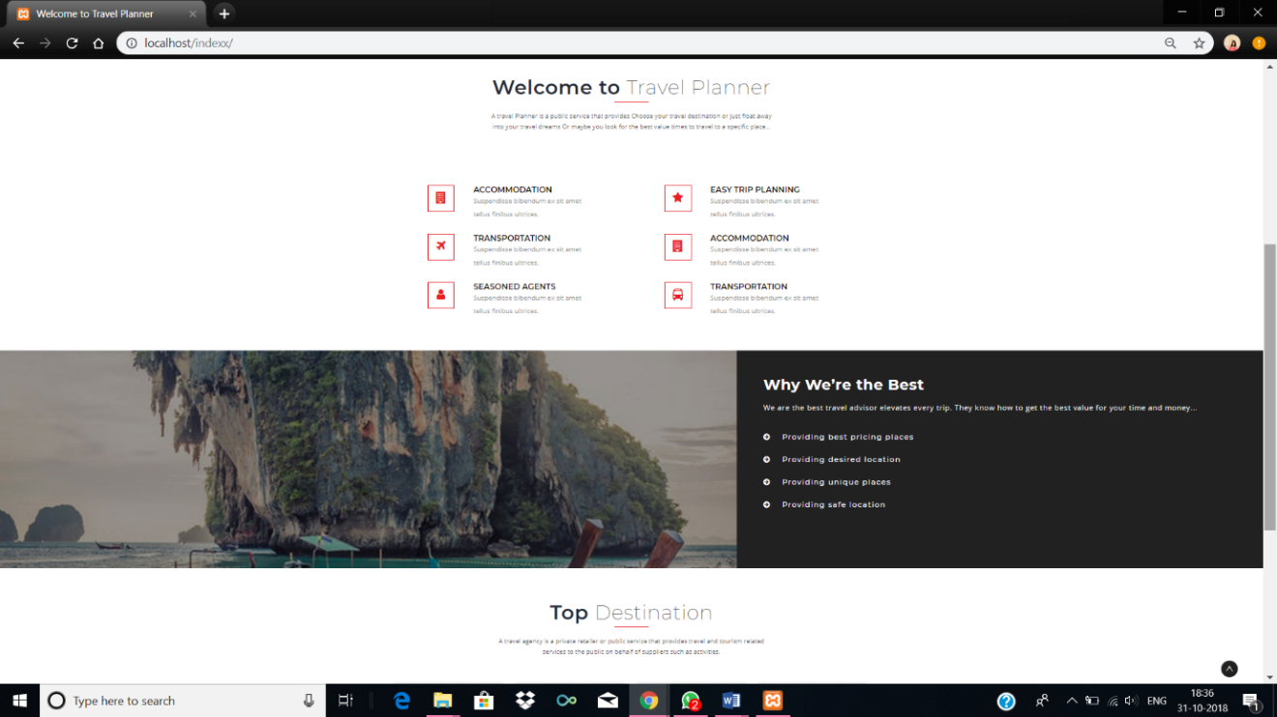

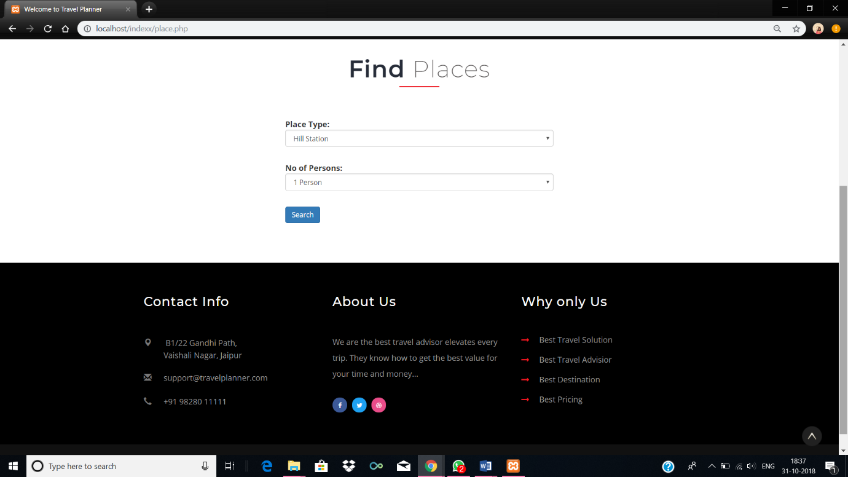

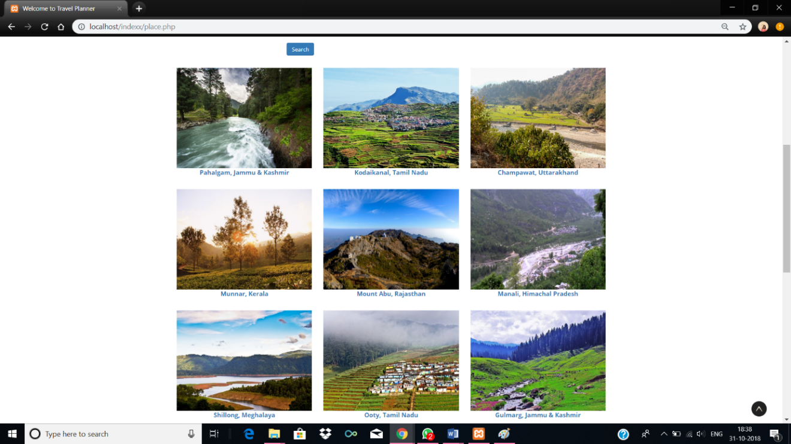

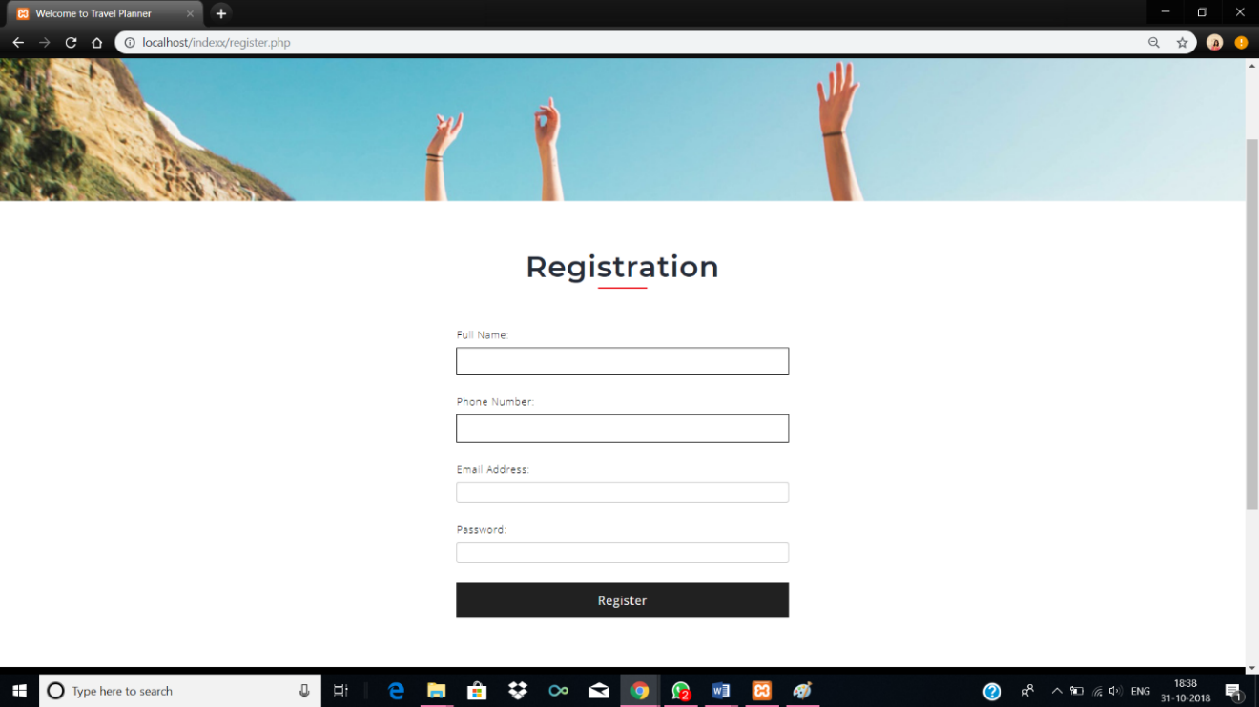

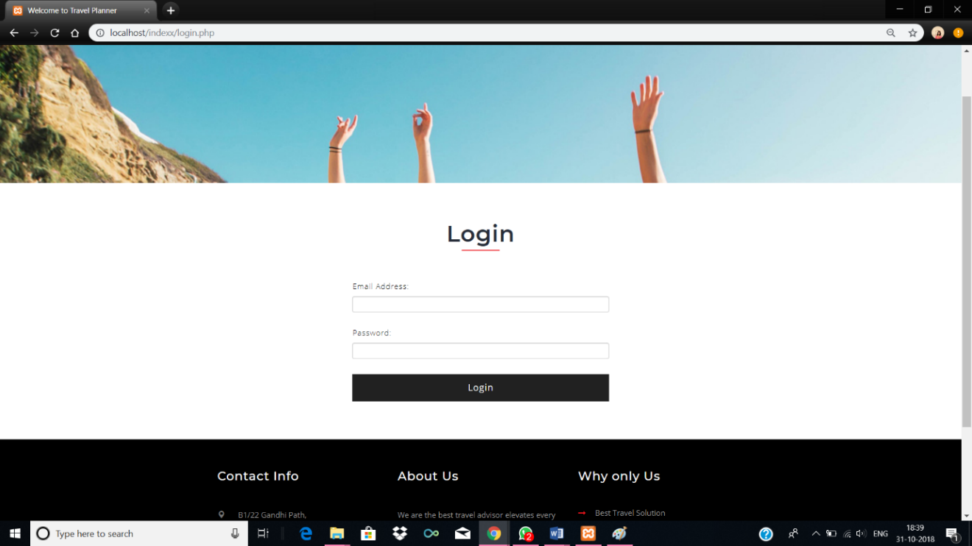

**References**

w3schools.com

tutorialspoint.com

**CHAPTER 5:**

**TEST CASE DESIGNS**

**CHAPTER 6:**

**CONCLUSION AND FUTURE SCOPE**

The software package allows for a platform to implement the following new things:

1. Improvement of Algorithm for planning of trip

2. User feedback-based evolution of data base

3. News updates and flashes about the city through appropriate information source

**CHAPTER 7:**

**FAQ ABOUT PROJECT**

1. What is the application of your project?
2. What is the total projected cost of your project including hardware, software and other requirements?
3. What are the constraints and capacity of your project?
4. What are the hardware and software requirements to run your project?
5. What is the future scope of your project?
6. Does your project have security features implemented? What are those features?
7. What is the core technologies included in project development?
8. What is the architecture of project (2-Tier, 3-Tier, n-tier, SOA etc.) and corresponding components?
9. How the system developed by you is superior to other existing systems.
10. How many functional requirements you have implemented in the project?
11. To what extent Agile Methodology you have followed? State its outcome.

**REFERENCES**